**Practical No. 9**

**Aim:** To implement 8:1 multiplexer.

**Apparatus:** Multiplexer IC (74LS151), Connecting wires, Bread Board, Power supply, LED, DMM.

**Theory:**

In electronics, a multiplexer or mux is a device that selects one of several analog or digital input signals and forwards the selected input into a single line. A multiplexer of 2n inputs has n select lines, which are used to select which input line to send to the output.

An electronic multiplexer can be considered as a multiple-input, single-output switch i.e. digitally controlled multi-position switch. The digital code applied at the select inputs determines which data inputs will be switched to output.

A common example of multiplexing or sharing occurs when several peripheral devices share a single transmission line or bus to communicate with computer. Each device in succession is allocated a brief time to send and receive data. At any given time, one and only one device is using the line. This is an example of time multiplexing since each device is given a specific time interval to use the line.

In frequency multiplexing, several devices share a common line by transmitting at different frequencies.

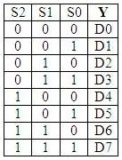

Truth Table of 8:1 MUX

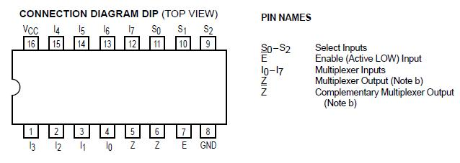

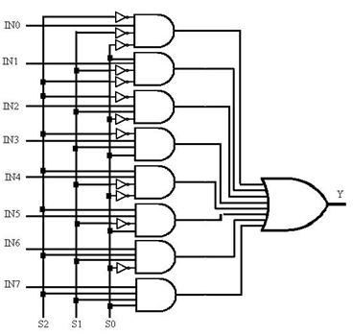

Logic Diagram of 8:1 MUX

**Procedure:**

1. Solve the problem given by lab instructor with help of 8x1 Multiplexer using implementation table method.
2. Find out the proper input and output as well as define the select line variable.
3. Use pin diagram and make proper connection as per requirement.
4. Measure the various output in LED on/off condition with different input condition. Note down the observation table.
5. Compare truth table with observation table and write conclusion.

**TinkerCAD Simulation BCD to seven segment:**

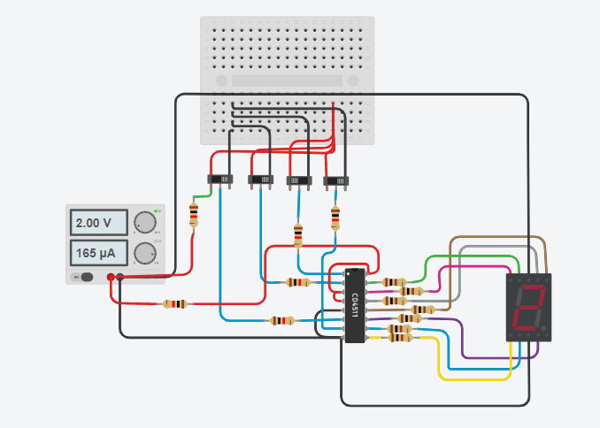

**Observation Table:**

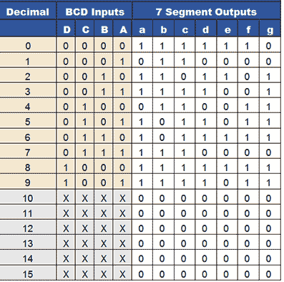

**Conclusion:**

We came to know that A multiplexer performs the function of selecting the input on any one of 'n' input lines and feeding this input to one output line. Multiplexers are used as one method of reducing the number of integrated circuit packages required by a particular circuit design.

Decoder is a combinational circuit that has 'n' input lines and maximum of 2n output lines. One of these outputs will be active High based on the combination of inputs present, when the decoder is enabled. That means decoder detects a particular code.